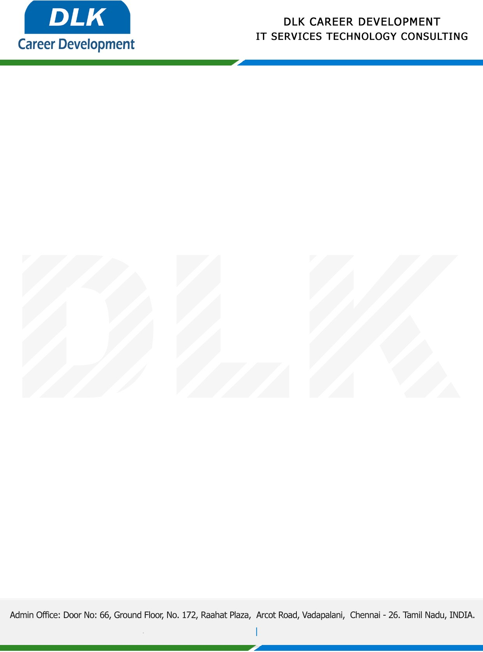

**Date: 23/ May /2023**

**SUB: PROJECT COMPLETION CERTIFICATE**

This is to certify that **MS JAYASREE V P (REG NO:** **2113092037150) MCA- Computer Application,** final year student **Dwarka Doss Goverdhan Doss Vaishnav College, Chennai** has Successfully Completed the Project Work under the domain of “**Blockchain”** in our organization during the Period **(23rd January 2023 to 10th May 2023).**

**Topic:** A Block Chain Based Approach for Drug Traceability In Health Care Supply Chain.

We appreciate your interest in **DLK CAREER DEVELOPMENT**

**“Best Wishes for Your Future Endeavors “**

